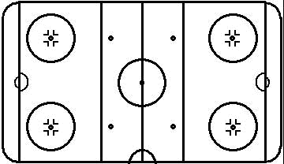


Vancouver TBirds

TEAM
Itinerary: Warm-up: Stretch/Run ( ), Pre-Game: ( ), Focus: ( ), Game time: ( )

Date:
Opponent:
Rink:

1) _____________________
2) _____________________
3)______________________
4) _____________________
5)_

Defensive Zone
________________________________________________________________________________________________________________________________

Neutral Zone
________________________________________________________________________________________________________________________

Offensive Zone
____________________________________________________________________________________________________________
Post Game:

Line-up
Opposition Scouting Report

L
R
_________________________________________________________________________________________________________________________________________________________

# )
# )
# )
# )
# )
# )
# )
# )
# )
# )

1)_____________________________
2)_____________________________
3)_____________________________
4)_____________________________
5)_____________________________

